### Miniature House #8 - Right V Front House

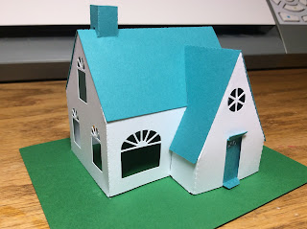

I updated my V front house and skewed the V to the right of the house. I added different windows and a chimney that is at the top of the roof line.  
  
I used card stock.